Assignment 3: Word count
1. Load file to hdfs -> hdfs dfs –put ‘employee.txt’
2. Load pig in mapreduce mode, ensure HistoryServer daemon is running.
Commands:
filedata = LOAD ‘employee.txt’ AS (fullline:chararray);
DUMP filedata;
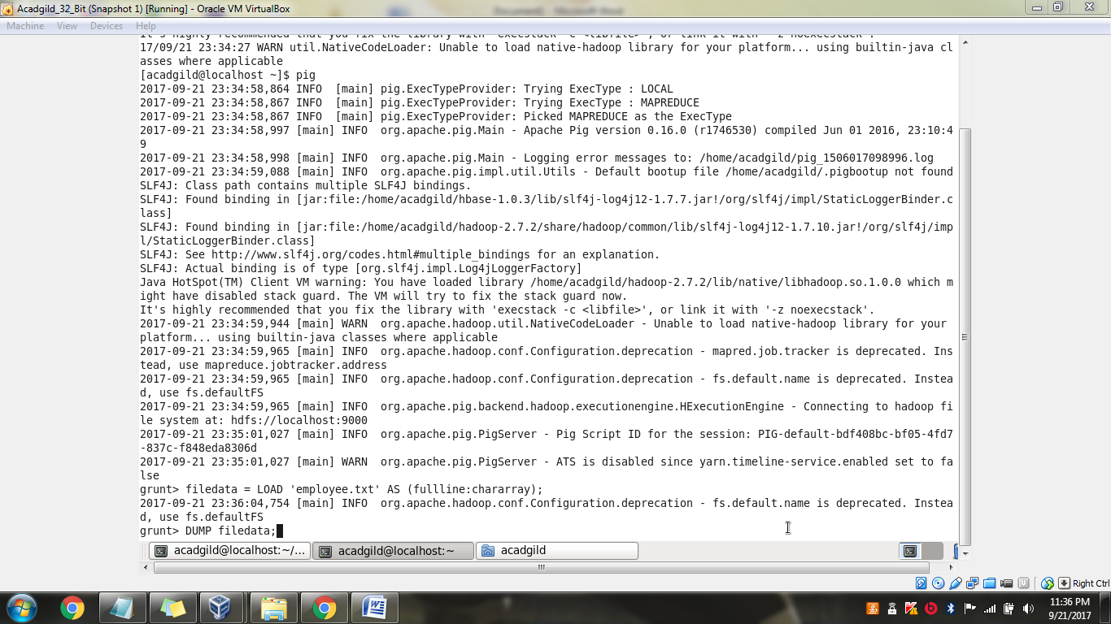

dataword = foreach filedata Generate FLATTEN(TOKENIZE(fullline)) as word;
DUMP dataword;
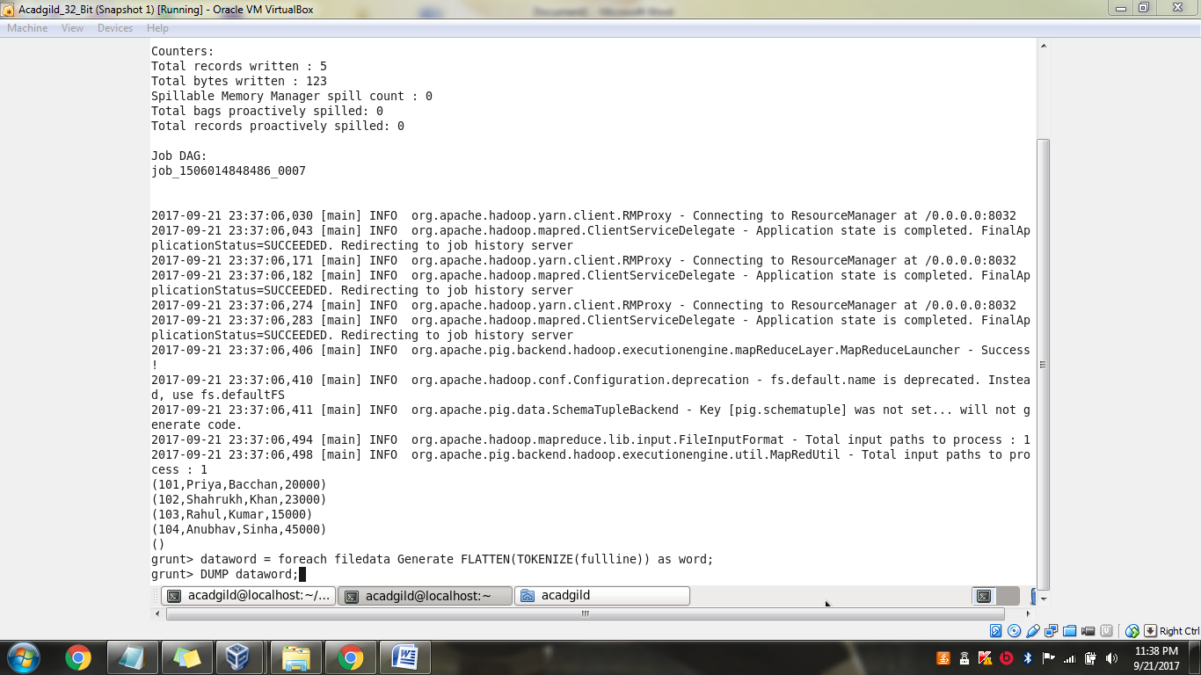
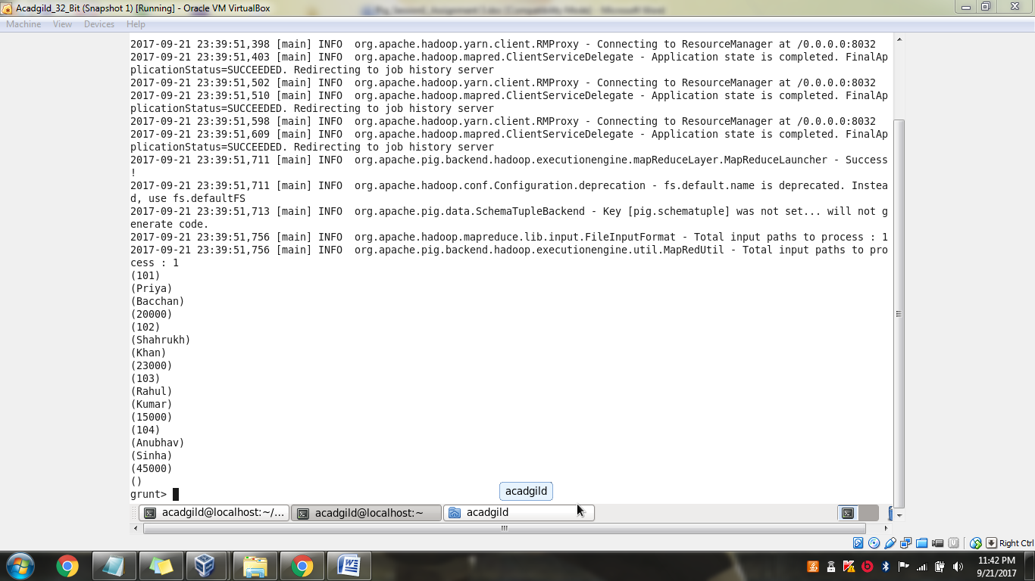

datagroup = GROUP dataword by word;
DUMP datagroup;
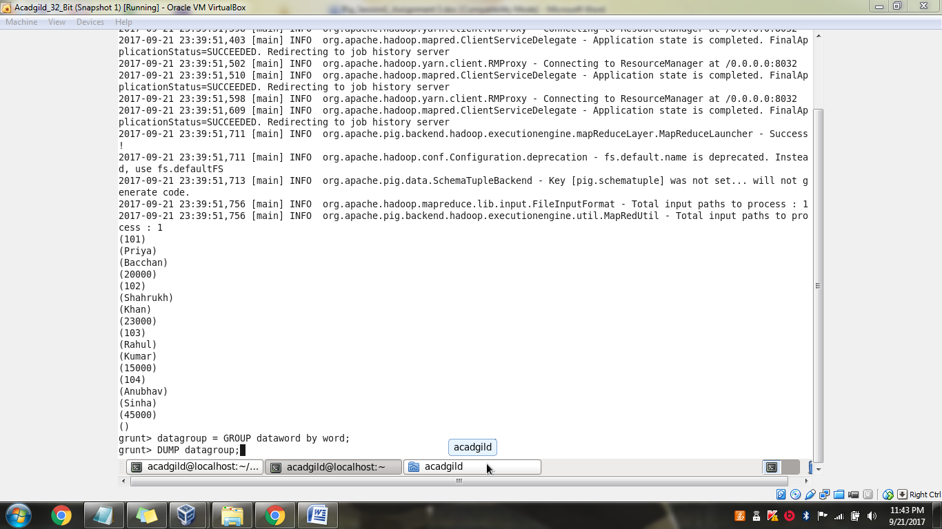
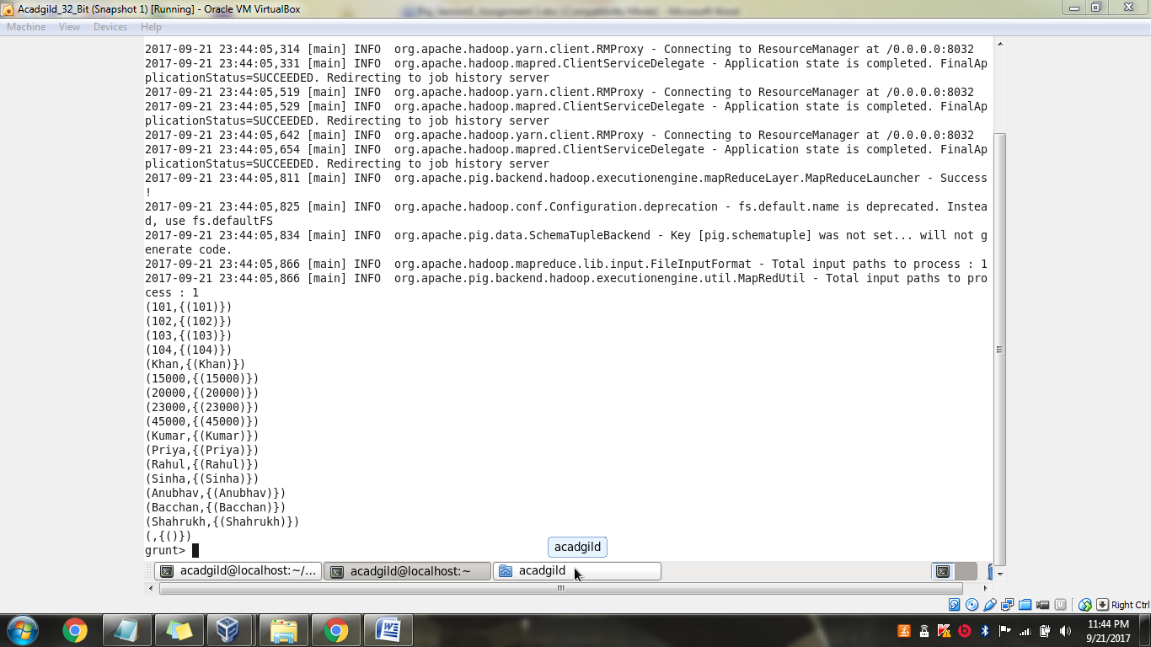

wordcount = foreach datagroup Generate group, COUNT(dataword);
DUMP wordcount;
